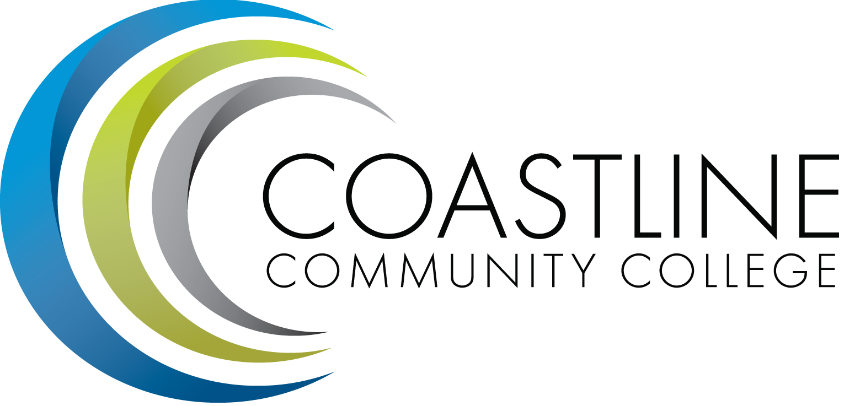
Planning, Institutional Effectiveness, and Accreditation Committee (PIEAC)
March 2, 2016
1:30 p.m. to 3:30 p.m.
Fourth Floor Conference Room

- CALL TO ORDER
  - Roll Call
  - Welcome
  - Adoption of Agenda
  - Approval of Minutes: February 17, 2015

- SPECIAL REPORTS/UPDATES
2.1 SharePoint C. Blackmore
2.2 PT Financial Aid Fraud Staff Position R. Miyashiro

- DISCUSSION ITEMS
3.1 Size of Committee V. Rodriguez
3.2 Committee Evaluation A. Zentner
3.3 Educational Master Plan Objective Development Team A. Zentner

4. ACTION ITEMS

4.1 Acceptance of SWOT Analysis Findings A. Zentner

5. STANDING REPORTS
5.1 Accreditation V. Rodriguez
5.2 Budget Committee R. Lockwood
5.3 Program Review A. Zentner
5.4 Grants D. Aistrich
5.5 President’s Report L. Adrian
5.6 Wing Reports V. Rodriguez, C. Nguyen, R. Miyashiro
5.7 College Council V. Rodriguez
5.8 Facilities C. Nguyen
5.9 Contract Education J. Groot
5.10 Student Success Committee Danny Pittaway
5.11 Other Committees Committee

6. ANNOUNCEMENTS (1-2 minutes per)

6. ADJOURNMENT

